CS 305 Project One Template

Document Revision History

Version | Date | Author | Comments
1.0 | September 27,2026 | Courtney McDonald | Initial vulnerability assessment report

Client



Developer
Courtney

- Interpreting Client Needs

Value of secure communications: Artemis Financial builds individualized financial plans covering savings, retirement, investments, and insurance, so its systems hold highly sensitive personal and financial data. Secure communications protect client trust and the company’s reputation, and a breach could cause direct financial harm to customers and legal exposure for Artemis Financial.
International transactions: The scenario does not state that Artemis Financial currently handles international transactions, but since it exposes a public RESTful API, it should plan as though clients or partners could connect from anywhere, since data-protection obligations differ by jurisdiction.
Governmental restrictions: As a financial services company handling customer financial information, Artemis Financial falls under regulations such as the Gramm-Leach-Bliley Act (GLBA), which requires safeguarding customer financial data, along with general data-protection expectations that apply to any company storing personal financial records.
External threats now and going forward: The manual review found hardcoded database credentials, REST endpoints with no authentication, and a cryptography library with known public vulnerabilities. Near-term threats include credential theft, unauthorized access to customer financial data through the open API, and interception of unencrypted traffic. Longer term, attackers increasingly scan for exactly these kinds of known CVEs in outdated open-source components, so the risk grows the longer these dependencies stay unpatched.
Modernization requirements: The application depends on several open-source libraries that are years out of date (Spring Boot 2.2.4, Bouncy Castle 1.46, Tomcat 9.0.30), each carrying known, publicly documented vulnerabilities. Modernizing means keeping these dependencies current and monitored with ongoing dependency scanning, moving to enforced HTTPS/TLS, and replacing the legacy cryptography library with a current, supported one.

2. Areas of Security

Input Validation: The business_name, name, and deposit amount parameters are all accepted from the client with no checks, so untrusted input reaches the application logic unfiltered.
APIs: The exposed REST endpoints (/read, /greeting) have no authentication or authorization, which matters a great deal for a financial company’s API.
Cryptography: The project depends on bcprov-jdk15on 1.46, a Bouncy Castle release from years ago with known vulnerabilities, and there is no HTTPS/TLS configured anywhere in the application, so this is the strongest finding overall.
Client/Server: The server accepts and processes whatever the client sends with no validation boundary between the two, which is a distributed-computing trust problem as much as an input-validation one.
Code Error: DocData catches its SQL exception but prints the full stack trace, which would leak internal connection details into logs.
Encapsulation: customer.java is inconsistent: account_number is private, but account_balance has no access modifier at all, so it is not protected the same way.
Code Quality is the one area I did not treat as a distinct finding for this app. The only pure code-quality issues (incomplete stub methods in myDateTime, an unused parameter in CRUDController) are incompleteness rather than a security flaw on their own, and every other code-quality-adjacent issue I found already falls under Input Validation or Code Error above.

- Manual Review

I manually reviewed CRUD.java, CRUDController.java, customer.java, DocData.java, Greeting.java, GreetingController.java, myDateTime.java, and RestServiceApplication.java. Findings:
- Hardcoded database credentials — DocData.java, read_document(): the database connection uses the literal username and password "root"/"root" written directly in the source code (CWE-798).
- Unimplemented, unsafe query handling — DocData.java, read_document(String key, String value): the key and value parameters are accepted but never used to build a query. If this is finished later with string concatenation instead of a parameterized query, it becomes a SQL injection vulnerability (CWE-89).
- Sensitive information exposure via error output — DocData.java: the SQLException handler calls e.printStackTrace(), which would print internal connection details to the console or logs (CWE-209).
- Missing authentication on REST endpoints — CRUDController.java (/read) and GreetingController.java (/greeting): neither endpoint checks who is calling before returning data (CWE-306).
- Unvalidated financial transaction input — customer.java, deposit(int a): there is no check that a is positive or reasonable, so a negative value would silently reduce the account balance (CWE-20).
- Inconsistent encapsulation — customer.java: account_number is declared private, but account_balance has no access modifier at all (package-private), so the class does not protect its fields consistently (CWE-668).
- Outdated cryptography library — pom.xml: bcprov-jdk15on is pinned to version 1.46, a Bouncy Castle release with multiple publicly documented vulnerabilities (see Static Testing).
- No transport-layer encryption configured — application.properties: there are no server.ssl properties set, so the application would run over plain HTTP by default (CWE-319).
- Oversized file uploads with no validation — application.properties: multipart uploads are enabled with a 200MB file size limit and 215MB request limit, with no visible check on file type or content (CWE-434).
- Unused, unvalidated input parameter — CRUDController.java: the business_name parameter is accepted but never validated or even used, indicating the input handling here was never finished.

4. Static Testing

I integrated the OWASP dependency-check Maven plug-in (already present in pom.xml, updated from version 5.3.0 to 12.1.0 since older versions no longer work against the current NVD API) and ran it against the code base. Scan summary: dependency-check version 12.1.0, scanned 38 dependencies (22 unique), found 13 vulnerable dependencies and 162 total vulnerabilities, with 0 suppressed.
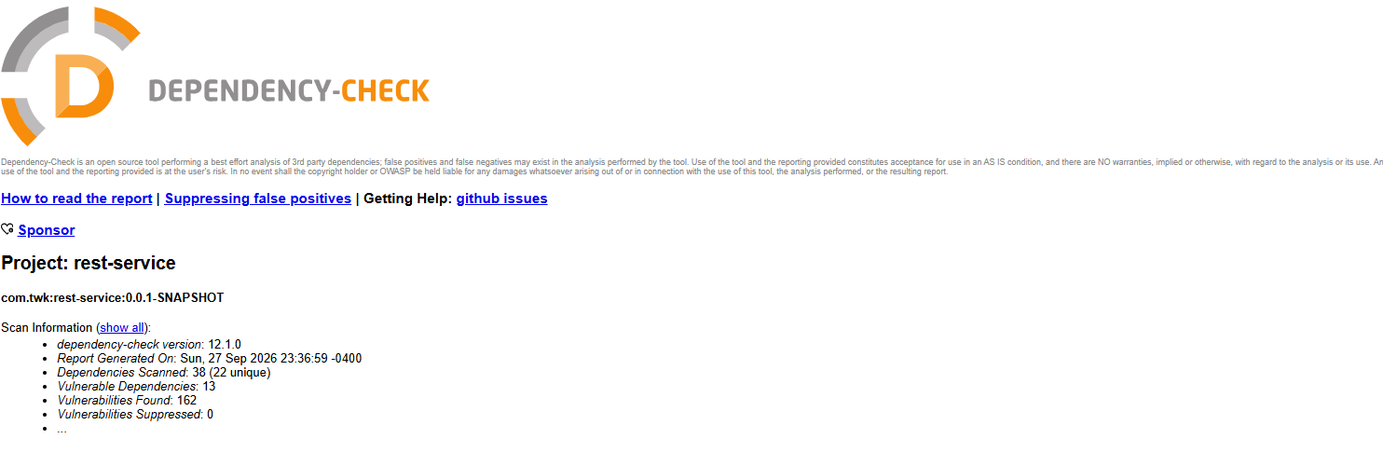

- Mitigation Plan

- Remove hardcoded credentials. Externalize the database username and password (environment variables or a secrets manager) and make sure real credentials are never committed to source control.
- Use parameterized queries. Implement read_document() with a PreparedStatement bound to the key/value parameters instead of any string concatenation, to close off SQL injection.
- Fix error handling. Replace printStackTrace() with a real logging framework (SLF4J) and return only generic error messages to API callers.
- Add authentication and authorization. Add Spring Security to the project and require authenticated, least-privilege access on /read, /greeting, and any future endpoints.
- Validate all input server-side. Reject negative or unreasonable deposit amounts, and validate business_name and name against an allowlist and a length limit.
- Fix encapsulation. Make all customer fields private, and only allow changes through validated methods rather than direct field access.
- Upgrade the cryptography library. Replace bcprov-jdk15on 1.46 with a current, supported Bouncy Castle release (bcprov-jdk18on) and re-run the dependency check to confirm the CVEs clear.
- Upgrade the Spring Boot parent. Moving off 2.2.4.RELEASE to a current supported release brings in patched Tomcat, Spring Framework, Jackson, SnakeYAML, and Logback together, clearing most of the remaining CRITICAL and HIGH findings at once.
- Enforce HTTPS/TLS. Configure server.ssl properties and redirect any plain HTTP traffic to HTTPS so client-server communication is encrypted end to end.
- Tighten file upload handling. Lower the upload size limits to what the application actually needs and validate file type and content before accepting an upload.
- Re-verify after fixing. Re-run both the manual review and the dependency check after these changes; suppress any dependency confirmed to be a false positive (like log4j-api) so future scans do not keep re-flagging it.

